John Bell CS235AM Term Project Proposal

For the Term Project I will be creating a simple to do list style calendar app.

The main view will be a list view of the upcoming calendar items.

Selecting an Item will open up a details view which will allow you to edit or delete the item.

There will also be an option to add a new event.

I would LIKE to also be able to import a calendar, for example the calendar presented on moodle but I'm not sure if I'll be able to figure it out in the time allowed since we don't cover file uploads or anything.

There is no need for save state on the main activities because it is just filling data from a database however the edit and add new event items will save state so you won't have to re-enter data after rotating the device.

The Edit Event and Add Event Activity will be the same.

MAIN ACTIVITY – List Activity

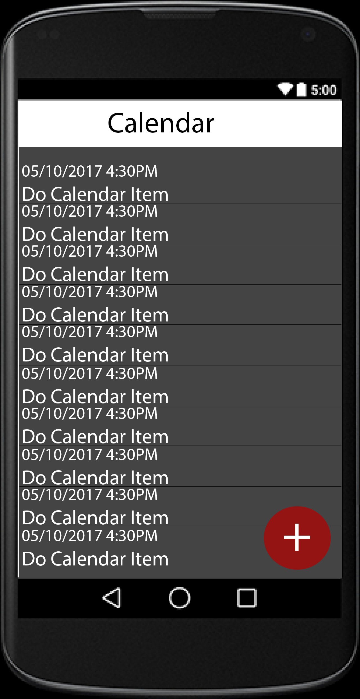
SECOND ACTIVITY – VIEW DETAILS (List Item Click Event Leads Here)
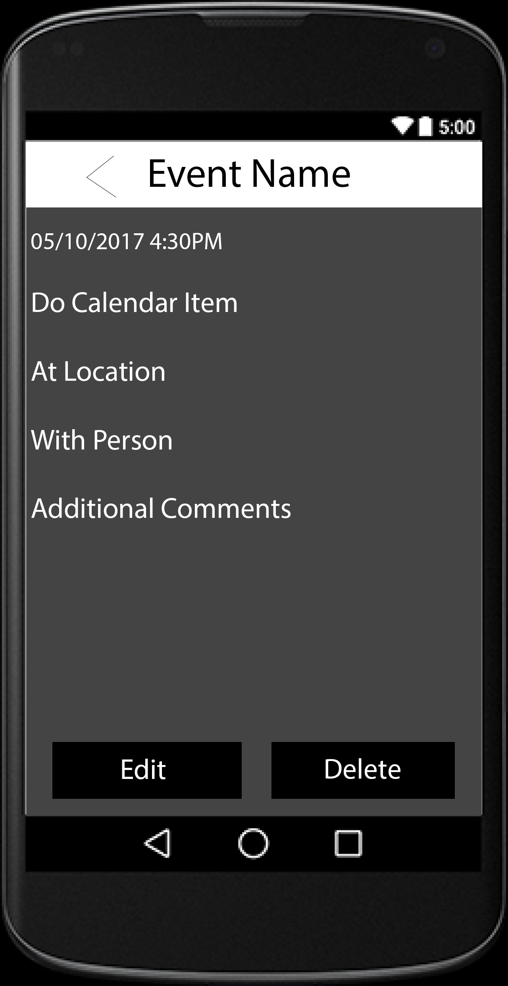
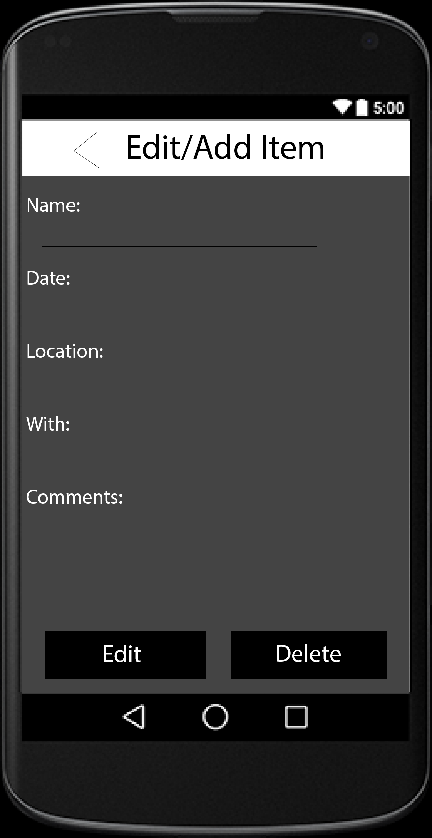
THIRD ACTIVITY – ADD/EDIT ITEM (Edit from View Details Activity OR Add Event Leads Here)

